Assignment of Benefits Form
Patient: ________________________________________________________________________
Social Security #/ Ins ID #: _____________________________________________________________________
I herby instruct and direct ___________________ Insurance Company to pay by check made out and mailed to:
Full Motion Physical Therapy
31461 Rancho Viejo Road, Suite 101
San Juan Capistrano, CA 92675
If my current policy prohibits direct payment to Full Motion, I hereby also instruct and direct you to make out the check to me and mail it as follows: Patient Name, C/o Practice Name, and Practice Address.
For the professional or medical expense benefits allowable and otherwise payable to me under my current insurance policy as payment toward the total charges for the professional services rendered. THIS IS A DIRECT ASSIGNMENT OF MY RIGHTS AND BENEFITS UNDER THIS POLICY. This payment will not exceed my indebtedness to the above-mentioned assignee, and I have agreed to pay, in a current manner, any balance of said professional service charges over and above this insurance payment. A photocopy of this Assignment shall be considered as effective and valid as the original. I also authorize the release of any information pertinent to my case to any insurance company, adjuster, or attorney involved in this case. I authorize Full Motion to initiate a complaint to the Insurance Commissioner for any reason on my behalf.
Financial Responsibility Statement
Full Motion Physical Therapy will bill the insurance carrier as a courtesy to the undersigned patient. The patient, however, is responsible for the bill in its entirety at the time services are rendered. If the insurance company of record requests a refund of payment made, this will also be the responsibility of the patient. In the event your company establishes an internal usual and customary fee schedule, it will be the responsibility of the patient to take care of the remaining difference no later than 30 days post treatment. If the patient claims W/C benefits and is denied this claim, the patient will be responsible for the total amount due for services rendered.
A holder of this medical debt contract is prohibited by section 1785.27 of the Civil Code from furnishing any information related to this debt to a consumer credit reporting agency
Estimated Patient Cost Per Visit:
The patient’s estimated remaining deductible is $ ________ (per your insurance company) which you are also responsible to pay as specified by your insurance benefits. Full Motion Physical Therapy estimates that your payment per visit (co-pay/co-insurance) is: $ _______The patients out of pocket maximum for the year is $________. Only then will insurance cover at 100%.
In addition, estimated coverage information is provided only as a guideline, but does not release patients from total responsibility for their account.
I understand and agree that if I fail to make any of the payments for which I am responsible, I will be held responsible for ALL costs of collecting monies owed, including but not limited to court costs, collection agency fees, attorney fees, etc.
_________________________ _________________ ________________ __________________
Signature Date Time Witness

Patient Information Form
Name: _____________________________________________________________ Date: ___________
Home Phone: ____________________ Cell Phone: ____________________
Would you like to receive text message reminders? Yes______ No______
Email Address: ________________________________________
(Initial) _____I would like to receive appointment confirmation by email, and I understand my email account may not be secure.
Home Address: ________________________________________
City/State: ______________________________ Zip Code: ___________________
Social Security #: _________________________ Date of Birth: _______________
Primary Care or Referring Physician: _________________________ Phone: ____________________
Whom may we contact in case of an emergency? ___________________________________
Relationship to Patient: __________________ Phone: ____________________
Patient Treatment Consent
I, the undersigned, do herby agree and give my consent for Full Motion Physical Therapy to perform medical care and treatment in order to properly diagnose and/or treat his/her physical and/or mental condition.
HIPAA Acknowledgement
I acknowledge that Full Motion Physical Therapy has supplied me with a copy of their health information privacy notice regarding their policies concerning my Protected Health information. I agree to release authorization to Full Motion Physical Therapy for the purpose of treatment, billing and communication.
In addition, I give Full Motion Physical Therapy permission to communicate with the designated person(s) below.
___________________________________________________________________________________

I certify this information is true and correct to the best of my knowledge. I will notify you of any changes in my insurance status or the above information.
___________________________________ ____________________
Signature Date

Medical History Information
Name: _____________________________________________________________ Date: ___________

What are you being treated for? :_______________________________________________________ 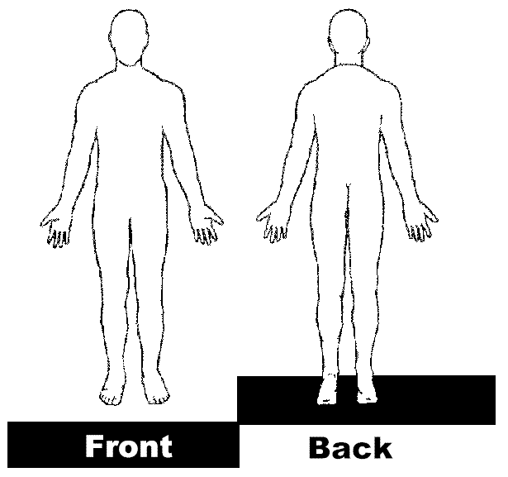

How long have you had symptoms or Surgical Date: ____________________ Any Other Surgeries pertaining to this problem? Yes____ No___
*Check any or all that apply to your present health or family health history*

- Heart attack
- Headaches
- Swelling
- Pace maker
- Shortness of breath
- Chronic pain
- Fatigue
- Arrhythmias
- Allergies
- Depression
- Prostate problems
- Heart disease
- Vision problems
- High/low blood pressure
- Cancer/tumors
- Incontinence
- Blood clots
- Pregnancy
- Nausea
- Night pain
- Stroke
- Weakness
- Seizure
- Metal implants
- Allergic to latex
- Diabetes
- Blood in stool/urine
- Thyroid problems
- Numbness/tingling
- Hearing loss
- Rheumatoid arthritis
- Dizziness
- Osteoporosis

Other medical conditions: ___________________________________________________________________
Have you had a fall within the last year? Yes________ No______ How many?___
Height ______ Weight___
X-Ray or MRI?: Yes___ No___ Describe results:_________________________________________
List all prescribed medications: ___________________________________________________________________________________
Please rate your pain levels on a scale of 0-10 (0 is NO pain, 6 wakes you up at night, and 10 being the worst pain imaginable) Level of pain at its worst ____ Level of pain at its best _____ Current Level _____
Describe your pain: Check ALL that apply: ___ Aching ___ Burning ___ Tingling ___ Numbness ___ Sharp ___ Dull ___ Throbbing ___ Cramping
What seems to aggravate your condition the most? ___ Sitting ___ Standing ___ Walking ___ Climbing Stairs ___ Laying Down ___ Lifting ___ Reaching What seems to help the most? _____________________________

Important Company Policies
Name:______________________________
We strive to provide you the best personalized care available. To make this possible we adhere to a set of very important policies. Please read them carefully, initial ALL proper spaces, and indicate your agreement by signing the bottom.
Please Initial
____ Co-Pays are due at time of service. If you happen to forget your wallet or checkbook we may still be able to see you upon completion of an “Extension Request” form. This is a “promise-to-pay” form and carries a minimal fee that allows you to keep your appointment. For your convenience Full Motion accepts Visa, MasterCard, Discover, Cash or Personal Check. Note: A $25 fee will be placed on all returned checks.
____ 24– Hour Advance Notice Fee. If you wish to change or cancel an appointment we require a minimum 24-Hour advance notice. Anything less will result in a $20 fee charged to your account. Advance notice allows someone else (who needs it) time to reserve it in place of you. Please be courteous and responsible. Thank you. If you accumulate more than 1 of these charges be advised that payment of at least one fee will have to be made before any other appointments can be scheduled.. If you continually miss or cancel appointments you will be dismissed from the practice. Please notify us of cancelation via phone call, DO NOT send us a text, we will not receive it and will result in a no show fee if a phone call is not received.
____ If you fail to show for an appointment without notice all future appointments will be removed and a $45 fee assessed to your account. You may re-schedule appointments again on a “first come, first serve basis”. If you accumulate more than 1 of these charges be advised that payment of at least one fee will have to be made before any other appointments can be scheduled. 3 or more no-shows will likely result in an automatic discharge.
____ Non-Covered Modalities Co-Pay. There could be an additional co-pay for modalities (laser, DMS, & spinal decompression) not covered by your insurance. You will be notified in advance as to what the co-pay is if it applies to you.
____ Late Policy “10– minutes” .Being late by more than 10 minutes will require you to either reschedule or wait for the next available opening. Though we will make every effort to fit you in, there are no guarantees since openings due to cancellations are unpredictable. Fees may also apply.
____ If a retroactive copay refund is requested, you will then be responsible for uncovered services per line item for each visit a refund is requested.

Credit Card to be held on file
Due to new California Law (SB 1060) we will now be requiring all new patients to provide a credit card to keep on file. This card will be used if there are any outstanding balances due that have exceeded their due date.
These balances include but are not limited to;
Late fees, No Show fees, Deductibles, Copays, Co Insurance etc.
We reserve the right to refuse service to anyone for any reason



Credit Card Information:
Name on card:________________________________________________________
Billing address:________________________________________________________
City:______________________________________ State:___ Zip Code:__________
Credit Card number:___________________________________________________
Experation date:____________
CVC/Security code:____________
Cardholder Signature:____________________________________Date:_________

